Grade 4 Set 1
The goal for teaching this set of lessons over the is to briefly introduce the concepts from each lesson, and to tell one or more episodes from each in both the mornings and afternoons (and have the children begin to develop the capacity to narrate these). If the children can learn at least the first three quotes and part of the prayer, that will be fantastic.
Have blank books prepared for the children to stick their work in as they learn. These can just be several A4 sheets of paper folded and centre-stapled into an A5 booklet.
You may also wish to have maps available for the children to map the significant events on. This could also be stapled into the booklet.
The children are also expected to complete a project that presents aspects of the life of Baha’u’llah. The sample below is a simple version without captions. It may also be presented as a display or collage (see Bicentenary examples on the next page). The bicentenary booklets also make a good resource for the children to refer to when working on this project.
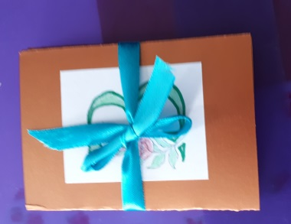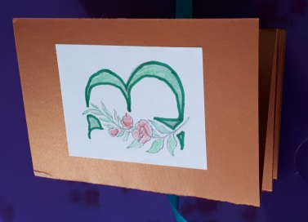
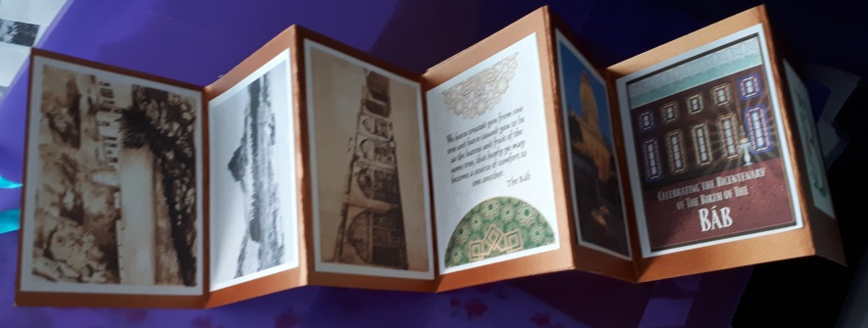
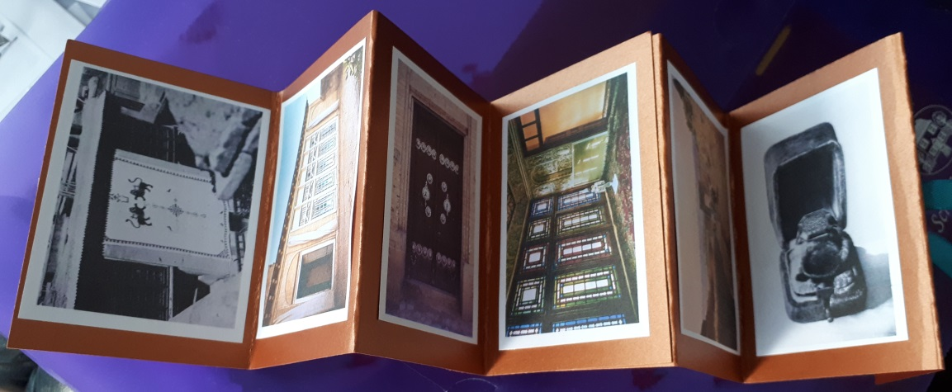
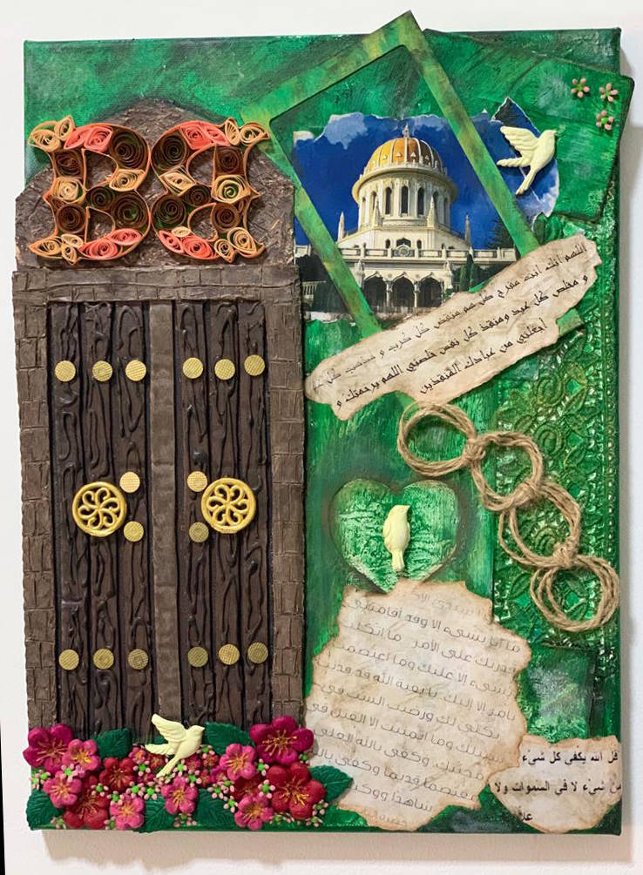
The play ‘The Birth of Baha’u’llah’ would be a good one to do with this set. This could be a final performance piece.

Songs:
Lesson 1 - We Will Have One World
Verily I Say
Lesson 4 - God is Sufficient, Remember My Days
Day 1 – Lesson 1

First Morning:
Have something for the children to do as they arrive, e.g. give them their booklets and get them to write their names on them (and get them to write ‘Baha’u’llah onto the cover in their best writing) or have a game running.
Start with devotions once the children have all arrived. Include a few songs the children already know if possible.
Introduce the purpose of the booklet and explain the project. Give the children time to discuss with a partner what form they would like their project to take. Explain that it can be a mixture of printed pictures, their own drawings/art, poems, captions, etc.
Teach the first few phrases in the prayer: “Magnified be Thy name…” with actions or pictures or a whiteboard rub-off (and symbols replacing words) and then get the children to glue this into their booklets. Give them the first verse to glue in initially, then the next one if they get to that. On the final day, give them the full prayer to stick in even if they haven’t learnt the whole thing by heart.
Teach them a song, e.g. ‘We Will Have One World’ or ‘Unite All’ https://soundcloud.com/jtdubss/unite-all?in=su-ellis/sets/grade-3-set-1
Set class guidelines collaboratively – get everyone to sign it.
Play a few getting to know you games, e.g. # 20 This is Me, #24 The Bridge Line Up or #19 Decisions, Decisions.

Lesson 1
First have a discussion about what they already know: (N.B. This is optional!)
- About the Baha’u’llah (this could be recorded as a brainstorm and put on the wall, or you could have four large pieces of paper with one sub-topic written in the centre of each (e.g. early life, teachings, followers, history of His Mission), and the small groups could circulate and add what they know to each one), or it could be done in small groups writing what they know on post-it notes/small pieces of paper which could be added to a combined display)
- What happened in their communities for the recent Bicentenary; then talk about how millions of people all over the world were celebrating the life of the Bab in just about every town and village on the planet. See if they also remember what happened for the Bicentenary of the Birth of Baha’u’llah in 2017. Ask them questions to elicit how far reaching His life and teachings have been.
- Ask if anyone has seen the film ‘Light to the World’ and what they remember about it.
Play a collaborative game (e.g. one of the above) if you need a break.
Introduce the principal theme, making sure to keep it a conversation with the children. Use the whiteboard to draw images to enhance understanding as needed.

Have the quotation written on A3 paper on the wall and help the children to learn it through actions or other method. Introduce the new words as you learn the quotation. The quote can be glued into their booklets.

Tell Vignette 2 and then Vignette 1 & get the children to draw rangoli on the concrete outside their classroom, but perhaps use tapa or kowhaiwhai patterns instead.
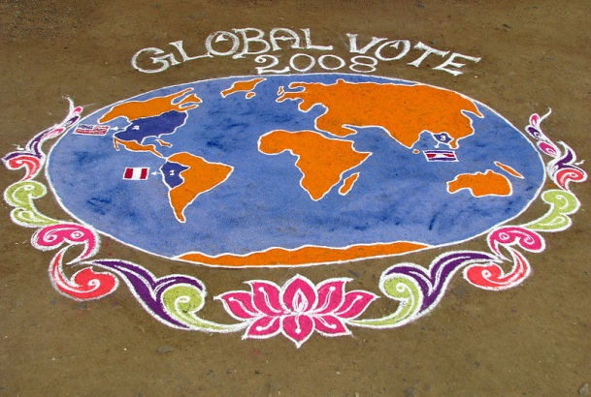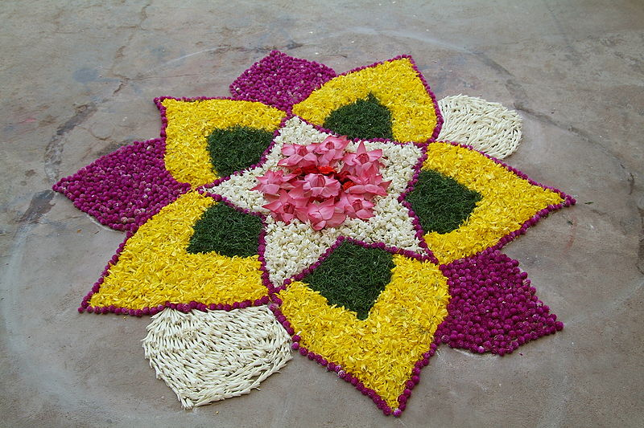

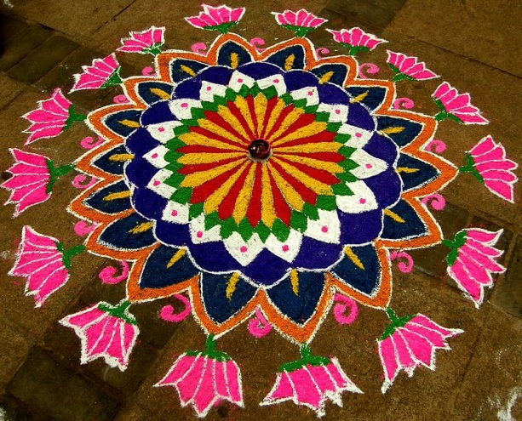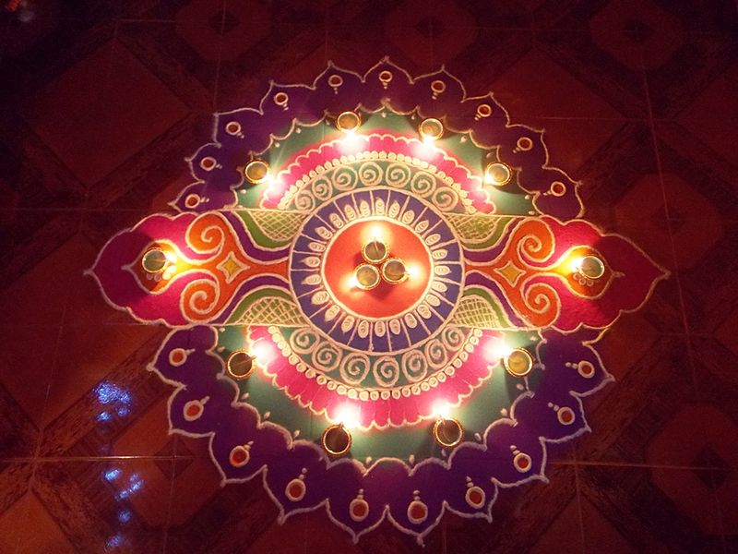

After the rangoli, tell Vignette 4. Discuss if there is a wall that could be beautified with a mural in their community. Were there other service projects they were involved in during the Bicentenary?
You could ask them to design a mural they would like to paint that expresses some of the teachings of Baha’u’llah.
If you have time, you can ask the children to try to write a poem about “The Bicentenary” as a haiku or acrostic, either individually, in pairs or collaboratively.
Day 1 Afternoon:

Review the part of the prayer learnt so far and add a few more phrases.
Sing the song from the morning again.
Possibly play another getting to know you game, e.g. #19 Decisions, Decisions.
Review the introduction to the principal theme, eliciting most of the concepts from the children.
Review the quotation.
Tell Vignette 3.
Get the children to retell the story in pairs.
Tell Vignette 6. This time, get the children to sit or lie with their eyes closed imagining the event. Ask them what aspects of the event made an impression on them. Ask the children to think about what kind of presentation they would like to give for the end of summer school. Perhaps get them to work in groups of four to plan before sharing back with the group. (Vignette 9 might also be helpful).
Present the idea of the play ‘The Birth of Baha’u’llah’. If they like the idea, assign parts and have them begin to practice it immediately.
Learn the review quote using actions and then get the children to reconstruct the quote jigsaw style. With a big class, you could have four groups working concurrently to do this. Get the children to glue the review quote into their booklets.
Outside collaborative games, e.g. ‘Unity Circle’
If they didn’t do it in the morning and you have time, you can ask the children to try to write a poem about “The Bicentenary” as a haiku or acrostic, either individually, in pairs or collaboratively.
Another option would be to draw/paint the world lit up with all the Bicentenary Celebrations.

Finish the day with devotions, including the song/s learnt so far.
Day 2 – Lesson 2

Have something for the children to do as they arrive, e.g. have them try to reconstruct the quotes from yesterday or have a game running.

Morning
Begin with devotions, including the songs from yesterday
Practice the prayer and add a few new phrases.
Ask the children what they remember from yesterday & then review the quote from yesterday
Teach a new song, e.g. Verily I Say https://soundcloud.com/bahai-blog/verily-i-say-nadia-roshan (or just play this one during the art) or ‘Baha’u’llah’ https://songs.ruhi.org/
Give the introduction to the principal theme of this lesson, being sure to make it an interactive conversation with the children. It may be helpful to draw elements on the whiteboard for the children to follow.
Teach the quote through pictures (see below for an example) or actions. Have them stick it in their booklets.
The children should already be quite familiar with Vignette 1 (paragraphs 1 & 2), so, after asking ‘Do you remember the story of the dream of Baha’u’llah’s father?’, try to elicit as much of the story from them as possible, adding and correcting as necessary.
Afterwards, get the children into pairs to retell the episode. This could form the basis of an art activity.
Play a short game such as ‘What are you doing?’
Tell Vignette 2 (paragraphs 3-5).
Either have the children retell in pairs if this is working well – or do a ball toss retell in a circle (prompting as necessary). Get the children to make puppets for the characters in the story and try to retell the puppet play part.
Finish with some collaborative games and song review.

Day 2 Afternoon
Devotions
Prayer and song review
Practice the prayer and add a few new phrases.
Collaborative game
Review the principal theme, eliciting the main concepts from the children
Review the quote using a whiteboard rub off and replace with symbols technique.
Tell Vignette 3 (paragraphs 6-11) (or #2 if it wasn’t told in the morning). It may be helpful to draw up key points on the whiteboard as you go.
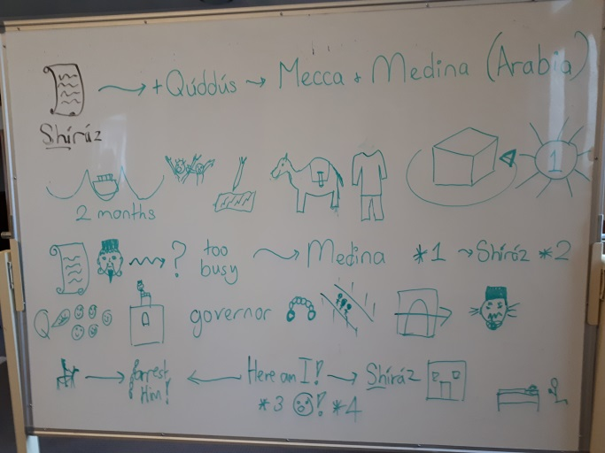
Get the children to retell the story in two or threes.
Following this, give the children the set of facts cut up to try to reconstruct. Or give them a sheet of paper with the first part of each fact, and give each child one of the complete facts. They then mix and mingle to try to find the answers for all the facts.
Alternatively, learn the facts for this lesson through a running dictation exercise, i.e. have the children work in pairs or groups of three. Place four facts at one end of the room and four at the other. One person writes while the other goes to look at the fact, memorises it and comes back to tell the writer. Only one person from a group may run at a time.
Draw or collage the puppet show or the dream of fishes.
Play some collaborative games outside.
Learn the review quote.
Conclude with devotions, including the songs to date.
Day 3 – Lesson 3
Morning

Begin with devotions.
Review the songs from the past two days.
Teach a new song: e.g. This is the Day https://songs.ruhi.org/ or Hemia Dei https://soundcloud.com/bahai-blog/hemai-dei-this-is-the-day-carmel-zein
Practice the prayer and add a few new phrases.
Ask the children what they remember from yesterday.
Give the introduction to the principal theme of this lesson, again ensuring it is an interactive conversation with the children.
Teach the new quote. Have the children stick it in their booklets.
Tell Vignette 1 (paragraphs 1 – 4), using the whiteboard to present key names, dates, symbols, etc. You could show the children a picture of Tihrán.
Ask the children to retell the story to each other.
Play the game ‘Yes, and… Yes, but…’
After morning tea, tell Vignette 2 (paragraphs 5 & 6) if possible as this part is a continuation of the previous episode. You could show the children a picture of Baha’u’llah’s ancestral home and the village of Takur. They could add the small pictures to their project.
After asking the children to retell it in pairs, get them to draw a picture of representing some of the ideas in the story, such as the clergyman with blocked ears, the hearts enlightened by the Message and the hundreds under the banner of Faith.
Play ‘Beatmaster’ or other collaborative game.

Day 3 Afternoon

Devotions, including some of the songs already learnt.
Review the prayer and add a few phrases.
Play a collaborative game, e.g. # 22 What are you doing?
Review the introduction to the principal theme, eliciting the content from the students.
Review the quote using actions.
Tell Vignette 3 (paragraphs7-9).
Get the children to work in groups to map out the key events related to this story on a large piece of paper.
Outdoor games
Either draw or collage a tent representing the Conference of Badasht. The children could either draw images to represent the past on the left side and others on the right to represent the bright future. Alternatively, the flaps of the tent could be open to reveal the glorious future through the other side.
Closing devotions

Day 4 – Lesson 4
Morning
Devotions including some of the songs already learnt.
Review the prayer.
Teach a new song, e.g.: This is the Day - https://songs.ruhi.org/ or ‘Remember My Days’ -https://soundcloud.com/steven-masua or ‘Bear and Endure’ http://bahai-song-project.de/bear-and-endure/
Play a collaborative game, e.g. state or mis-state a fact from one of the previous lessons and have the children run to one end of the room if it is correct, or the other end if it is incorrect.
Review the Lesson 3 quote.
Give the introduction to the lesson and read the quote. Get the children to glue the quote into their booklets.
Play a cooperative game.
After morning tea, tell the remainder of the episode (paragraphs 9 – 12). Teach the song ‘God is Sufficient Unto Me’ at the appropriate point in the story.
Retell the story in a circle.
Get the children into two teams to reconstruct the fact sentences.
Get the children to draw/collage a bright sun bursting out from behind dark clouds, calling to mind the dawning of God’s new Revelation in the darkness of the Siyah-Chal.

4th Day Afternoon

Devotions, including some of the songs already learnt.
Review the prayer.
Learn the review quote using actions.
For the remainder of the afternoon, make final decisions about performance items and practise these as well as complete unfinished artwork.
If there is time, you may wish to play a few more collaborative games, practise narrating the stories, review the memorisations, etc.
Another option is to work on a summary or collaborative artwork of the type below:
Be sure to close with devotions.
