Summer School BE180

Theme 2, session 2: Building Vibrant Communities

Introduction

“When the phenomenal sun appears from the vernal point of dawning in the zodiac, a wondrous and vibrant commotion is set up in the body of the earthly world. The withered trees are quickened with animation, the black soil becomes verdant with new growth, fresh and fragrant flowers bloom, the world of dust is refreshed, renewed life forces surge through the veins of every animate being, and a new springtime carpets the meadows, plains, mountains and valleys with wondrous forms of life. That which was dead and desolate is revived and resuscitated; that which was withered, faded and stricken is transformed by the spirit of a new creation. In the same way the Sun of Reality, when it illumines the horizon of the inner world...Then fragrant flowers of inner significances appear from the soil of human souls, and the whole being of man awakens to a new and divine activity.”
‘Abdu’l‑Bahá, The Promulgation of Universal Peace
Just like the light and warmth of the physical sun bring new life and energy to earth, the spiritual Sun, the Manifestations of God through Their life and through The Word of God inspire the soul and adorn the body of humanity with vibrant and purposeful communities.
Therefore, to build vibrant communities, we must learn to channel the power of the Word of God in our personal life and in the life of our community. The following quote refers to the “pattern of community life” that can help us channel this power:
“ … Bahá’ís are engaged in cities and villages across the globe in establishing a pattern of life in which increasing numbers, irrespective of background, are invited to take part.... This pattern of community life is giving rise to vibrant and purposeful new communities wherein relationships are founded on the oneness of mankind, universal participation, justice, and freedom from prejudice. All are welcome. The process which is unfolding seeks to foster collaboration and build capacity within every human group … to arise and contribute to the advancement of civilization.”
From a letter dated 27 December 2017 from the Universal House of Justice to an individual

- What is the “pattern of community life” that is “giving rise to vibrant and purposeful” communities? How does this pattern, which has emerged from the accumulating experience of the global Bahá’í community, draw on the Word of God?

Groups of families and friends building vibrant communities

As the pattern of activity strengthens, a noticeable shift occurs when groups of families and friends start working together to build vibrant communities. They regularly come together to study the Word of God and be inspired by it, they read the reality of their communities and plan on how they can work towards its material and spiritual advancement, they reflect on their action and always maintain an outward orientation to invite more and more souls to walk the path of service together.
In practice, this means the mobilization of a sizeable number of Bahá’ís who are creatively and intelligently applying the Plan’s framework for action to the reality of their own circumstances wherever in the cluster they live. It entails families and individual believers working together and making a conscious decision to see themselves as belonging to an expanding nucleus. Such groups of friends set about widening the circle of participation in their activities by engaging with the networks to which they belong—networks created through a place of work or study, a local school, or a community hub of another kind—and by accompanying others who arise to serve alongside them. These efforts have tremendous merit.
30 December 2021 message from the Universal House of Justice
to the Conference of the Continental Boards of Counsellors

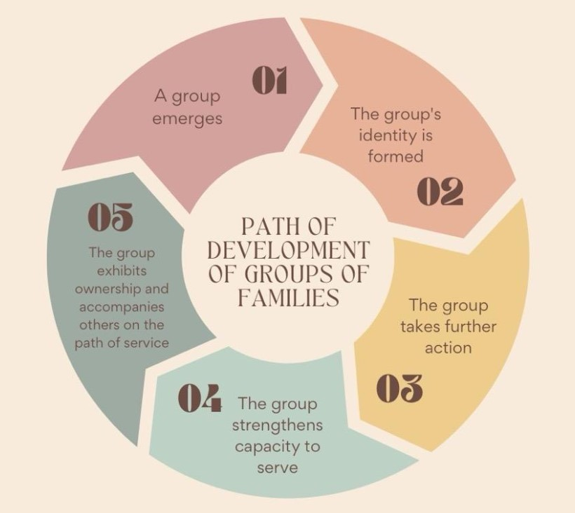

- Reflect on your community: are there any examples where groups of whānau and friends are working to build vibrant communities? Share some stories about how they collaborate and what effect their service has in the lives of their families and on the community.

Engaging whole families

Each of us is a member of a whānau, and at the same time we are all members of a community. Whānau is one of the structures that lends stability to a community and promotes social harmony. In fact, it is the most fundamental. The nature of the interactions within it, the way it conducts its affairs, and the habits learned by its members—these extend beyond the whānau unit and determine the character of any civilization that is to emerge.
- Share examples from your community on the effect engaging whole families in activities and educational endeavours has. How have regular whānau days helped in creating vibrancy in your community?
- What possibilities might exist in your locality to strengthen bonds of fellowship and solidarity among a few families that are part of the networks to which you belong? What conversations help open up possibilities for worship and elevated conversations that enhance the devotional character of your community?

Examples of the process of building vibrant communities from North Island

Video: Experience from Wellington and Waikato
- What were some of the changes that parents mentioned in their children?
- What are the ways the animators have been accompanying the families whose children are participating in the junior youth groups and camps?

Exploring the concepts through arts

