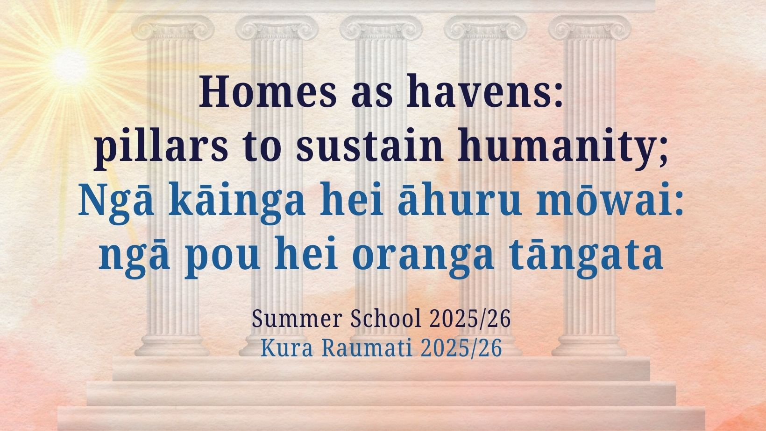

Dates:
Venue:
Host Assembly:

Bahá'í Summer School 2025/26
Contents

Vision for summer school 3
Venue information 4
Ground plan 5
Additional services 6
Striving for excellence (school rules) 7
Policy on guardianship of minors 9
Signed declaration for guardians of minors 10
Programme overview 15
Courses & facilities for children & junior youth 16
Children’s & junior youth classes timetable 17
Workshop facilitators & rooms 18
Sessions arranged by North Island Council 19
Sessions arranged by South Island Council 20
Sessions/workshops created at the local level 21
Evening Programme 22
Arts Workshops 23
Leisure, sports and other activities 24
Classrooms plan 25
Notes 26
Committee contact numbers 27

Vision for summer school

Welcome!
Summer schools have been a feature of Bahá’í community life in New Zealand for at least 80 years. In addition to providing an opportunity for participants to study the Bahá’í writings and to strive to obtain a more adequate understanding of their significance, this seasonal school allows families and friends to spend a period of time together in a joyful atmosphere conducive to learning and the strengthening of spiritual bonds.

“The world is undoubtedly facing a great crisis and the social, economic and political conditions are daily becoming more complex. Should the friends desire to take the lead in informing the world, they should start by educating themselves and understand what the troubles and problems really are which baffle the minds of men. It is in these Summer Schools that this training should be provided for the friends.”

— Shoghi Effendi, 1932

“The institution of the Summer School constitutes a vital and inseparable part of any teaching campaign, and as such ought to be given the full importance it deserves in the teaching plans and activities of the believers.”

— Shoghi Effendi, Unfolding Destiny

Venue information

Name of venue:

Suggested items to include:
- Address
- Historical Information
- Important things to know about-the venue
- Things to know about the town/area, supermarket, gas stations, other accommodation such as motels etc.
- Fire evac/first aid information

Ground plan

Provide a map of the venue
Additional services

Suggested items include:

- Registering for meals
- Cafe or tuck shop
- Youth Workshops

Striving for excellence

Personal Behaviour. Those attending Summer School are expected to adhere to Bahá‘í laws and principles concerning individual behaviour. These include, but are not restricted to courtesy, respect, punctuality, chastity, and honesty. Any problems or concerns about behaviour at Summer School should be directed to a member of the Summer School organising committee (see page 26).
Attendance. All Summer School participants are invited to see themselves as protagonists in an educational programme and encouraged to attend all classes, plenaries, workshops, and evening programmes. Unstructured time for socialising and conversation is available during breaks and meals.
Punctuality. Punctuality is a sign of consideration for other people. Please be punctual for sessions and meals. Drop off and collect children in your care on time.
Accommodation. Everyone is expected to respect the space and property of others.
Cleanliness. All participants are expected to help keep all spaces clean and tidy throughout the duration of Summer School and assist in keeping bathroom areas clean. Please sign up to volunteer for the many service jobs available during Summer School (see registration for more info).

Smoking. Please note that there is to be no smoking, including vaping.
Car Parking. Please be sure to park in approved or designated car parks.
Campers (if applicable). Please follow the tent setup plan available at the camp area. For more information contact ___.
Curfew. To ensure everyone can participate with enthusiasm and joy at Summer School, all main lights in the dorms will be out by 10.00pm. Out of respect and consideration for others, youth and adults should be back in their sleeping quarters no later than 11.30pm.
- All junior youth and children (15 and under) are to be in their sleeping quarters no later than 9.30pm (or earlier depending on the wishes of the parents). Parents or guardians are expected to ensure that this happens.
Guardianship of Minors. All attendees at the Summer School are responsible for the love and care of our children. Anyone who is registering a minor (under 18yrs) attending Summer School without their parent/s MUST read the Policy on Guardianship of Minors before registering.
Responsibility for children and youth under 18. When children and junior youth (aged 14 and under) have been signed out from their classes, they are to be in the care, both day and night, of their parent/s and/or guardian/s. These adults should know where they are, what they are doing, and who they are with during these times and should ensure that they are participating fully in the Summer School, eating well, etc. The committee thanks parents and guardians for their co-operation in helping to provide nurturing and safe boundaries for our precious children. When sessions are running, all those under 18 are to attend classes, workshops and sessions according to the programme; or to be serving in some capacity.
Youth room. …
Out of bounds areas: …
Security. ... Please report all incidents to ___ or a member of the Summer School organising committee.

Policy on guardianship of minors
Care of children and youth under 18

Any child or youth under 18 years of age attending Summer School without their parents must:
- Have a responsible adult to act as their guardian while he or she is at Summer School.
- The Summer Schools Committee must be provided with the guardian’s and parent’s information and the guardian’s mobile number will be added to the lanyard or registration tag/label for the child/youth.

Parents must make it clear to the guardian that the guardian has overall responsibility for their child, which includes, but is not necessarily limited to the following requirements.
The guardian is expected to:
- Sleep in the same area as their charge i.e. in the dormitory, the gym sleeping area or the camping ground. In all cases the guardian must sleep near the child. This means that a girl must have a female guardian, and a male guardian is needed for a boy. In special circumstances, an exception may be made by the committee after consultation with the parent institution.
- Monitor the health and well-being of their charge e.g. eating meals
- Ensure that their charge is attending all classes for their age group.
- Be readily available to their charge for the duration of Summer School i.e. ensure that the child/youth knows where they are at all times.
- Deal with any issues or problems that may arise.
- Ensure that their charge is behaving according to the Summer School rules and Bahá’í standards.
- Ensure that their charge is abiding by the curfew which is appropriate for their age group.
- Act in place of parents if any misbehaviour is reported.
- Act in place of parents in the event of the child needing medical attention e.g. taking the child to a doctor or hospital, administering medication.

Refer to next page for signed declaration. The Summer School committee should make this form available at registration.

As a host Assembly, you may prefer to copy the contents of this page into a separate document so that it is printable as a loose-leaf form. This will allow it to be made available for signing at registration.

Signed declaration for guardians of minors

I have read the above policy about my responsibilities as a guardian for the minor/s named below and I agree to abide by them:

1) _________________________________________

2) __________________________________________

3) __________________________________________

Name of guardian: _____________________________

Contact Mobile number:________________________

Signature: ____________________________________

Date: __________________________________

This page should be extracted and retain

Time | Day 1 (Fri 27) | Day 2 (Sat 28) | Day 3 (Sun 29) | Day 4 (Mon 30)
A.M.
9:00 – 10:30  Video Presentation & Workshop | Constructing a peaceful society | Humanity’s coming of age | Building a refuge for mankind | Becoming true practitioners of peace
10:30 – 11:00 | Morning Tea | Morning Tea | Morning Tea | Morning Tea
11:00 – 12:30
11:00 – 12:30 | (Coinciding children’s and junior youth sessions) | (Coinciding children’s and junior youth sessions) | (Coinciding children’s and junior youth sessions) | (Coinciding children’s and junior youth sessions)
P.M.
12:30 – 2:00 | Lunch Break | Lunch Break | Lunch Break | Lunch Break
2:00- 3:30

3:30 – 4:00 | Afternoon Tea | Afternoon Tea | Afternoon Tea | Afternoon Tea
4:00-5:30 | Recreational activities for all ages | Recreational activities for all ages | Recreational activities for all ages | Recreational activities for all ages
5:30 – 7:00 | Dinner Break | Dinner Break | Dinner Break | Dinner Break
7:00-8:30 | Evening programme | Evening programme | Evening programme | Evening programme
Please note this is just a suggested schedule and host Assemblies are completely free to adjust and organise it in any way that best suits their needs.
Classroom plan
a map of classroom locations

Provide a map of the classroom locations within the venue
Notes
Committee contact numbers

Thank you for attending the ……………..Summer School.
We hope you have an enjoyable time!

Summer school organising committee

Role | Name | Phone contact



